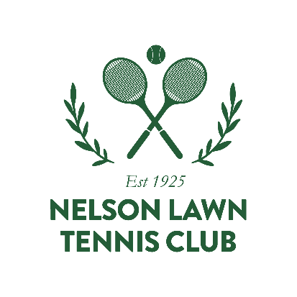
A Guide to Membership at Nelson Lawn Tennis Club – 2020/21
With the new season almost upon us (1st October), here’s a useful guide to explain how our membership fees are structured.
You’ll be pleased to hear that membership fees remain unchanged for the new club year. All membership categories and fees for 2020/21 can be found on our website.
Many of our members have joined the club half way through the year and some have benefited from our pandemic special. If you have loved playing tennis at Lawns and would like to sign up for a full year of tennis, here’s the low down on what’s on offer.
Membership Fee Structure
At first glance our membership options can appear overwhelming – with so many options to choose from.
We have two main categories for juniors, adults & seniors (over 65’s). These are:
- Social Membership – for members who just want to play socially and who don’t want to play interclub or rep tennis
- Competitive Membership – for anyone who wishes to take part in interclub (league) tennis and rep fixtures (i.e. representing Nelson Bays)
The main difference in membership fees for social and competitive categories takes into account the extra NBTA affiliation fee and team fees for taking part in interclub.
Under social membership we have a great offer for families who wish to play together and enjoy the benefits of coaching from Calder Tennis. Sign up for our family membership and the kid’s membership is free.
Under our competitive options, the Student Competitive package is for those juniors who play Senior Interclub.
Affiliated Membership
Affiliated membership is available to adult and senior players whose main membership is with another club. There are social and competitive options here.

New Membership Category
At our AGM on Wednesday 26th August, we agreed to introduce a winter membership which will run from April – September. This special offer will be open to new members only.
Need to talk to someone?
Still not sure about which membership to sign up for? Please let us know and we’ll be happy to help.

Based on $150 for adult social membership. Our family membership is designed for 2 adults and 2 children; for social play only.

