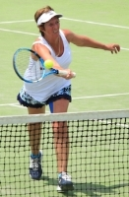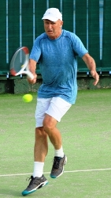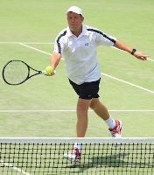

**Age Singles Doubles Mixed  
 Pts Rank Pts Rank Pts Rank  
Women 35+** Sela Corbett 0400 89 0190 64  
 Wendy Jambor 0280 47  
**Men 40+** Rodney Cook **0**400 36  
**Women 40+** Glynnis Carolissen 0280 60  
Craigie McCulloch 0190 83 **Men 45+** Giilies DeGouy 1730 24 1525 37 2100 04  
**Women 45+** Trudie Von Huben 0562 72 2100 03  
 Julia Sim 0400 94 0400 50  
**Men 50+** Mike Clapshaw 0400 76  
 Jeff Crichton 0400 76  
**Women 50+** Julie Heaton 0400 68  
**Men 55+** Philip Seeman 1480 32 1575 30 1275 15  
 Mike Callard 0425 78  
 Peter Stokes 905 100 0400 88  
**Women 55+** Deanne Alter 0400 76  
 Karen Cranston 1025 58 0830 34  
**Men 60+** Peter Hampton 0885 97 3675 02 2575 03  
 John Lawrence 1050 74 0905 83 1230 08  
 Sam Dean 0400 75  
**Women 60+** Penny Smith 0820 74 1225 42  
 Helen Litt 0675 100 0975 60 0400 66  
 Marietta Duffy Burgess 0705 44  
 Jeanette Elley 0400 66  
**Men 65+** Quentin Maisey 1615 33 1075 18  
 Larry Seales 1925 22 0975 23  
 Stephen Temple 2550 08  
**Women 65+** Sue Jamieson 1830 10 2350 10 2350 04  
 Victoria Kerrison 0670 37  
 Trish Craven 1000 35 0655 38  
**Men 70+** Dave Meredith 0280 71  
 Max Morrison 0400 49  
**Women 70+** Sandy Tritt 1195 39 1630 20 1525 10  
**Men 75+** David Theyers 0800 62 0400 32  
 Michael Ross 0800 62 0280 41  
**Women 75+** Gloria Wilmot 0280 87 0400 64 0280 31  
 Jeanette Harding 0400 68 0095 46  
 Beverley Evans 0400 64 0280 31  
 Janice Larmer 0280 83 0400 26  
 Myrna Hyde 0095 46  
**Men 80+** Evan DelaRue 0400 75  
 Gary Pike 0400 25 0400 14  
 Keith Burt 0140 21  
**Women 80+** Margaret Hall 0095 79  
 Mary Durham 0095 79 0140 22  
 Tup Cox 0400 47  
 Jillian Roberts 0280 58  
**Men 85+** Ashley Wilson 0990 29 0750 25 0575 07

**RANKINGS**These rankings are taken from the ITF Rankings as at   
**3 September 2019** and covers those in the top 100

**ITF SENIORS PLAYER RANKINGS**

**2019**