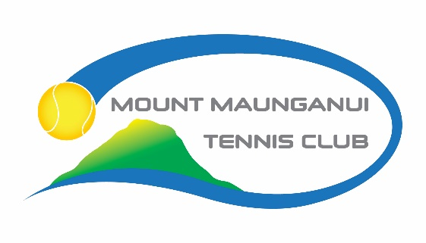

CLUB SHIRT ORDER FORM
A range of stock and sizes are available for you to try on at the tennis club

NAME: PHONE: EMAIL:

 | ITEM | SIZE(S) | QUANTITY | UNIT PRICE $  (INC GST) | LINE TOTAL $  (INC GST)
 | Youth Tee  Sizes: 10y, 12y, 14y |  |  | $31.00
 | Ladies Racer Back  Sizes: 12, 14, 16 |  |  | $37.00
 | Ladies Tee  Sizes: 12, 14, 16 |  |  | $39.00
 | Ladies Polo  Sizes: 10,12,14,16 |  |  | $45.00
Ladies Singlet
Sizes: 10,12,14,16
 | Mens Tee  Sizes: S, M, L, XL |  |  | $40.00
 | Mens Polo  Sizes: S, M, L, XL |  |  | $43.00
GRAND TOTAL $
Payment made on: by: Eftpos DC Cash
(DATE)
Collected Yes No

Please email your order form to tennis@mounttennisclub.co.nz
If paying by Direct Credit our bank account details are 031547 0001458 00 and please use your name and “uniform” as reference
Please allow up to 4 weeks if we need to order your size in. You will be notified when your order is available to collect from the club.

