Pompallier Lawn Tennis Club (PLTC, the club)
Covid Vaccination Policy
Background

The Government has announced a new COVID-19 Protection Framework (Framework) under which we will adopt a ‘traffic light’ approach to managing COVID-19, including through the use of vaccination certificates.
Our members recently had the chance to provide us with comments regarding the club’s options for operating under the Framework, and we thank the more than 130 of you who took the opportunity to respond (we currently have approx. 350 members in total). As expected, we received a range of views, and it is clear there are strong feelings around the operational options the government has provided to clubs like ours.

The inputs into our policy decision making include:

- general guidance from Sports NZ, Tennis NZ and Tennis Auckland (ongoing)
- the health and safety of our members and contractors and our associated obligations
- the objects of the club stated in PLTC constitution, which can be found here.
- your survey responses (if anyone would like a copy of the survey results, please email our manager Nikki on manager.pompallier@gmail.com)
- discussions with Nikki regarding workload and capacity to monitor and enforce.

What is apparent from our survey is that the club has very few unvaccinated adult members - the vast majority of our players who are unvaccinated are juniors (who are ineligible to receive the vaccination, currently). Children who are unvaccinated (under 12 years and three months) are considered as vaccinated for purposes of the Framework and we will treat them as such for the purposes of this policy.

With so few unvaccinated adult members, we will be able to operate in a manner that doesn’t put undue burden on the manager in terms of enforcement (beyond the general requirement that would apply if the club were to be closed to all other than those able to produce a current My Vaccine Pass (MVP)), doesn’t restrict access for members holding a current MVP, and doesn’t take away the ability of unvaccinated members to continue to play tennis at our club, although we do recognise and acknowledge the significant restrictions imposed on their access and rights to partake in a variety of activities and events. We look forward to the time when the club is able to operate again without any restrictions for any of our members.

Risk assessment

When considering the various factors above, we have used a rule of thumb to test our proposed rules and restrictions established by this policy, which is:

“in allowing unvaccinated members to continue to access the club, would a vaccinated members playing at the club have any greater exposure to unvaccinated people than they would to being exposed to an unvaccinated person as they walk down a footpath”.

When assessing the new rules and restrictions, our conclusion is no – the risks to our members are the same.

Members will continue to be in control of their exposure, largely without any impact on their typical engagements with the club – members control who they play against and with on a court (the only time this might change is on social nights or events the club organises like competitions and club champs, hence the restrictions). High risk areas such as indoor areas (international data highlights the minimal chance of infection in outdoor settings) are limited to current MVP holders and this will be monitored and enforced. Please note that Sports NZ and Tennis NZ guidance for monitoring and enforcement compliance is “reasonable” efforts. We believe the procedures we are putting in place, along with the natural division of our club into fenced zones, exceed the legal requirements.

One area of cross contamination that might be of concern for members relates to balls crossing from one playing court to the other. Attached is a study that highlights the very remote likelihood of such contamination, but should any members be concerned, we ask any players so concerned not to touch balls straying onto their courts.

https://www.ncbi.nlm.nih.gov/pmc/articles/PMC7350886/

Should you have any queries or concerns around this policy, please do not hesitate to contact Shane, shane@freshinfo.co.nz or
Craig, squire.mac@mac.com

Covid 19 Policy

To have the best chance possible of ensuring compliance with our health and safety obligations, reducing the risk of exposure to, and transmission of, COVID-19, and operating safely and optimally at all levels of the Framework, while being true to the objects of the club as set out in our Constitution, the PLTC committee (Committee) has confirmed a new COVID-19 policy pursuant to clause 7 C xii of the PLTC Rules as follows:

This policy will expire on 31 March 2022 unless renewed or updated by the Committee on or before that date.

- We strongly encourage all our eligible adult members to get vaccinated, and to acquire and maintain a current MVP.

- PLTC will restrict the access to certain facilities, events and programmes of any member over the age of 12 and three months who is unwilling or unable to present a current MVP (other than a member with a valid exemption, as determined by the manager in her sole discretion), in accordance with the Restrictions set out below, as amended from time to time. Certain restrictions will also extend to non-members including contracted coaching staff, visitors, spectators and non-member playing partners and service providers (for specific details, see below).

- The PLTC Manager (Manager) and the Manager’s specific delegates (if any) will be the sole parties responsible for determining the current MVP status of any member or other applicable parties. No other Committee member, or PTLC member shall be entitled to enquire as to the vaccination status of a member, and PLTC will not store or retain personal data beyond the information captured using the government's tool for determining a valid MVP and confirmation of verification and MVP expiry date linked to membership.

- The Committee will review and amend this policy as new information comes to light, including as regards changes in levels and any other information the Committee thinks relevant.

- Should any members be uncomfortable with the implementation of this policy (whether vaccinated or unvaccinated) PLTC will allow the member to terminate their membership and will grant a refund (pro rata) for any paid fees. Alternatively, PLTC will offer the affected member the chance to suspend their membership for a specific period of time.

- The Committee will continue to comply with any and all legal requirements imposed as part of the government’s Covid-19 response. In particular, the Committee will comply with the requirements associated with events and gatherings that have caps on attendance numbers based on the applicable Framework setting from time to time and the Committee may invoke special rules and restrictions in order to comply with such requirements.

- There is a zero-tolerance approach applied to any hostility or aggression towards the Manager or her delegates as a result of her/their implementation of this policy. The Manager and her delegates are simply implementing the policy as decided by the Committee and any PLTC member or other third party on PLTC grounds breaching this provision will be asked to leave and may be banned permanently from the club.

Restrictions in force from 15 December 2021 to 31 March 2022 (the Initial Period)

 | Vaccinated | Unvaccinated
New Membership | Yes | No
Private tennis
Access to Zones 1,2,5 (other than as relates to Events) | Yes | Yes
Access to Zones 3 and 4 | Yes | No
Events
Social tennis organised by the club | Yes | Unable to attend
Other Events and Gatherings that may result in the club NOT being able to operate within the government capacity limits may be amended from time to time. | Yes | Unable to attend
Coaching
Individuals | Yes | Yes
Groups | Yes | No, except with the express agreement of all members of such group and the relevant coaching staff, and always subject to the capacity restrictions imposed under the Framework

The water fountain will remain closed.

“Vaccinated” for these purposes means all current members aged 12 and three months and under, all other members holding a current MVP as verified by the PLTC manager or her delegates and anyone medically unable to be vaccinated, as verified to her satisfaction by the manager or her delegates

“Unvaccinated” means any member not falling in the definition of Vaccinated.

"Event” means any club organised function or recreation event that is considered an Event for the purposes of the Framework.

“Gathering” means any unorganised sports and recreation activities. See below for defined spaces applicable to each such gathering.

The Manager may declare certain events and gatherings to be "MVP only", meaning that notwithstanding the ability of the event to meet the capacity restriction based on the vaccination status of attendees, only vaccinated people (as defined above) may attend.

For the purposes of the Framework the Manager may also declare any and each zone of the club a “defined spaces” for the purposes of any event/gathering activity or series of events/gatherings provided that such a declaration does not run contrary to the restrictions set out above. For the purposes of the Framework, Zone 1 is a defined space and Zone 2 is a defined space.

“Zones" means each zone as identified in the aerial photo on page 7 of this document, as amended from time to time.

Details on third parties

- Contracted coaching staff - on court - the club requires all on-court coaching staff to be vaccinated and hold a current MVP.

- Spectators (including parents) - treated as unvaccinated and subject to the restrictions stated above unless the Manager is satisfied the person holds a valid exemption or current MVP or is under 12 years and three months.

- Unless approved by the Manager in advance (and in all such cases the Manager must have seen each such player’s current MVP in advance of entry to the club, such details are recorded in the non-members register maintained for such purposes by the club, and the person must be recorded in the club’s booking system), third party non-member adult playing partners of PLTC members are unable to play tennis at the club for the duration of the Initial Period.

- Third party service providers (other than contracted coaching staff) - the Manager in their sole discretion to determine whether to require third party service providers to prove they hold a current MVP vaccination status depending on the service to be provided and the area to be accessed (and any other factors the manager determines relevant to the service to be provided).

- For the avoidance of doubt, the contracted coaching staff are treated as “members” for the purposes of this policy.

Pompallier Lawn Tennis Club Zone Map – for the purposes of the Covid Protection Framework Policy

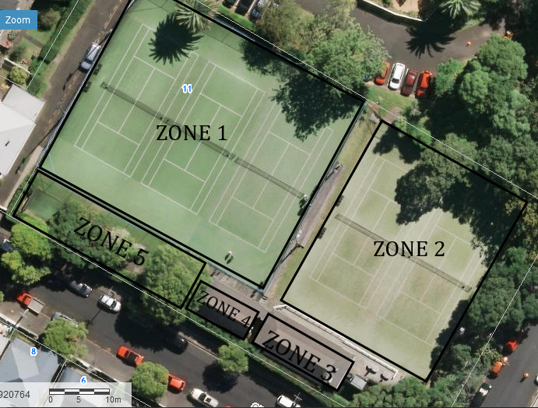
Zone 1: Courts 3, 4 and 5
Zone 2: Courts 1 and 2
Zone 3: The Clubhouse – this does not include the deck area outside the clubhouse
Zone 4: The bathrooms – this does not include the seating area outside the bathrooms
Zone 5: Grass/Path area and hitting wall

Please note, all areas outside of a zone within the Club are accessible by all members

